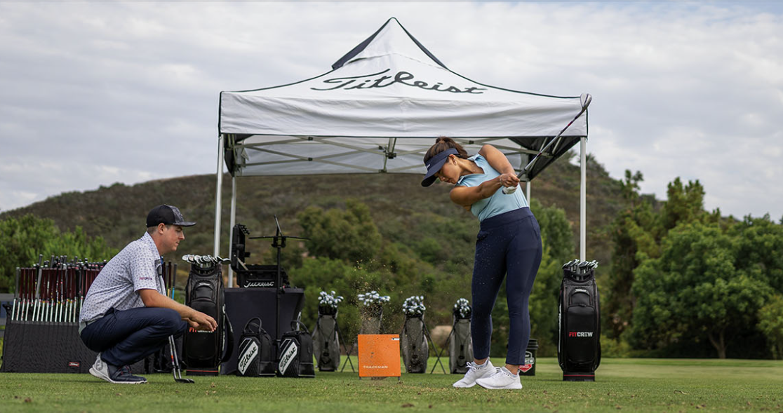

Object Specification - Reports / Forms

Functional Specification – Technical Specification – Release Notes

|  |  |
| --- | --- |
| Document Name: | **FTP-R-143 Custom Report for Cell Production - Clubs** |
| Document Version: | 1.0 |
| Document Status: | In Progress |
| Document Update Date: | 02/20/2025 |



**Program *EXCEL*erate**

***Transform today, Excel tomorrow***



**Program *EXCEL*erate**

***Transform today, Excel tomorrow***



**Program *EXCEL*erate**

***Transform today, Excel tomorrow***

# Document Information

|  |  |
| --- | --- |
| Item | Description |
| Initial Author | Abhilash Ramarao |
| Object Specification Name | FTP-R-143 Custom Report for Cell Production - Clubs |
| Blueprint Specification Reference | <customer code><project code><document type><<Workshop Reference #>-<Workshop Description>-<Date in Mmmddyy format>NA |
| Document Version | 1.0 |

|  |  |
| --- | --- |
| Client Source | <Functional Team or Area> |
| Priority | Choose a priority. |
| Core Team Owner: |  |
| Contact Number: |  |
| Email: |  |
| Completed On: | Click here to enter a date. |
| Functional Spec Completed By: | Abhilash Ramarao |
| Contact Number: | +91-9743362062 |
| Email: | Abhilash.ramarao@rizing.com |
| Completed On: | Click here to enter a date. |
| Functional Spec Approved By: | Bert Oetsen |
| Contact Number: |  |
| Email: | [Bert_Oetsen@Acushnetgolf.com](mailto:Bert_Oetsen@Acushnetgolf.com) |
| Approved On: | Tuesday, February 25, 2025 |
| Technical Spec Completed By: | Gizala Kanuga |
| Contact Number: |  |
| Email: | Gizala.kanuga@rizing.com |
| Completed On: | Saturday, March 01, 2025 |
| Technical Spec Approved By: |  |
| Contact Number: |  |
| Email: |  |
| Approved On: | Click here to enter a date. |
| Development Assigned To: | Gizala Kanuga |
| Contact Number: |  |
| Email: | Gizala.kanuga@rizing.com |
| Completed On: | Saturday, March 01, 2025 |
| Development Approved By: | Chuak Fen Soo |
| Contact Number: |  |
| Email: | [Chuakfen.soo@rizing.com](mailto:Chuakfen.soo@rizing.com) |
| Approved On: | Monday, March 03, 2025 |
| Off-Shore QA Approved By: |  |
| Contact Number: |  |
| Email: |  |
| Approved On: | Click here to enter a date. |
| On-Site QA Approved By: |  |
| Contact Number: |  |
| Email: |  |
| Approved On: | Click here to enter a date. |

**Document History**

|  |  |  |  |  |  |
| --- | --- | --- | --- | --- | --- |
| Version | Description | Author | Prepared/ Modified Date | Reviewed / Approved By | Approved / Reviewed Date |
| 1.0 | Initial release | Abhilash Ramarao | 20-Feb-2025 |  |  |
| 1.1 | Technical Specifications | Gizala | 01-Mar-2025 | Chuak Fen Soo | 03-Mar-2025 |
| 1.2 | Characteristics added | Abhilash Ramarao | 18-June-2025 |  |  |

# Documentation Roles

This describes who or what function is responsible for completing the various sections in this document.

**Business Requirements** – this section to be completed by the Business (Core Team) with the support of the Functional Consultant

**Functional Specification** – this section to be completed by the Functional Consultant with the support of the Business

**Technical Specification** – this section to be completed by the Technical Consultant with the support of the Functional Consultant

**Security** – this section to be completed by the Functional Consultant and the Technical Consultant

**Quality Assurance** – this section to be completed by the QA Team

**Release Notes –** this section can be completed by any team. They can add any notes relevant to the different release

**Appendix** – this section to be updated, as needed, by any involved parties

# Table of Contents

1. Business Requirements 7

1.1 Business Drivers and Justification 7

1.2 General Requirements 7

2. Functional Specification 8

2.1 Type of Execution 8

2.2 Selection Criteria 8

Selection Criteria 8

Fields Required on the Selection Screen 9

2.3 Special Processing Notes 9

2.4 Output Layout 11

2.5 Detail Information 13

2.6 Data/Process Flow Diagram 14

2.7 Data Volume 14

2.8 Performance 15

2.9 Service Level Agreement 15

2.10 Operation Level Agreement 15

2.11 Gaps, Outstanding Activities and Risks 15

2.12 Security 15

3. Technical Specification 17

3.1 Assumptions 17

3.2 Clean Core Compliance Checklist 17

3.3 Development Overview 18

3.4 Detailed Design 18

3.5 Security 21

3.6 QA Scope and Plan 22

3.7 Test Scenarios & Data 22

4. Release Notes 22

4.1 Developers / QA team / Consultant Notes 22

5. Appendix 22

5.1 Links 22

1. Business Requirements
   1. Business Drivers and Justification

Clubs summary report generated based on the Inventory storage location and posting date once after the goods receipt. This report gives the total number of product posted to stock inventory based on the date and inventory location.

Along with this, the characteristic data also shown in the report which is maintained during sales order creation.

* 1. General Requirements

*(Describe the following general requirements related to this report.)*

|  |  |
| --- | --- |
| What is the processing frequency for this report? |  |
| What is the expected volume/data load for this report? | Summary report of cell production |
| What type(s) of business data will be contained in this report? |  |
| Who will be receiving this report? | Production report |
| What is the output method for this report? |  |
| What is the delivery method for this report? |  |
| Is this and ad-hoc or a batch report? |  |
| What is the transaction where this will get attached? | (Please use this row in forms related specifications only) |

1. Functional Specification
   1. Type of Execution

This report gives the summary report of products which are done with goods posted to inventory based on the posting date and the maintained inventory storage location.

To generate this report we need to create new custom Fiori app.

In this report we can view the cell production report and cell production detail report based on the selection.

* 1. Selection Criteria

Selection Criteria

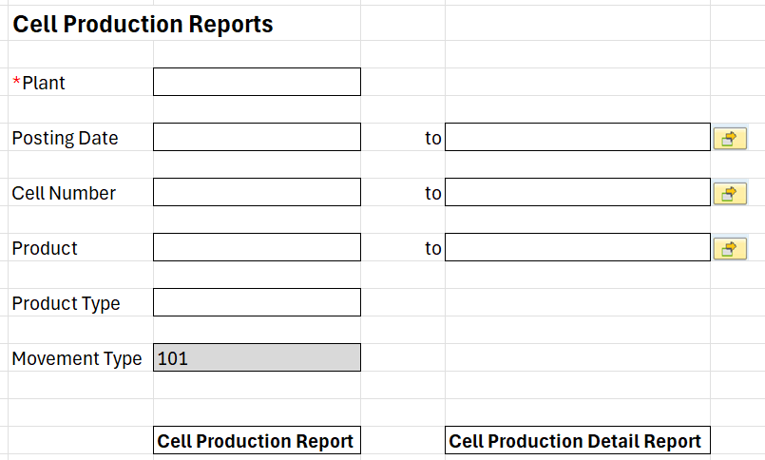

In the selection screen, plant is default since it is clubs plant. We need to enter posting date of the production order and goods inventory storage location or based on the product we can generate the report.

From selection screen we can generate two output reports

1. Cell Production report (without sales order, production order and Characteristic values)
2. Cell Production report (with sales order, production order and Characteristic values)

Fields Required on the Selection Screen

|  |  |  |  |  |
| --- | --- | --- | --- | --- |
| Field Name | Field Source | Multiple Selection | Range Selection | Mandatory |
| Plant |  | No | No | Yes |
| Posting Date |  | Yes | Yes | No |
| Cell Number |  | Yes | Yes | No |
| Product |  | Yes | Yes | No |
| Product Type |  | No | No | No |
| Movement Type |  | No | No | No |

* 1. Special Processing Notes

Refer below logic to get production orders with goods receipt completed.

Pass DWERK (selection) in AFPO table and get all AUFNR

Pass all AUFNR to MSEG table and check BWART=selection

Pick all goods receipt completed production orders for the report.

This report will pick all the orders which are done with the goods receipt status.

If the posting date is different for same product, then in the report it will show in different rows.

|  |  |  |
| --- | --- | --- |
| **Field** | **Field description** | **Logic to fetch the data** |
| NLPLA | Cell Number | Pass AUFNR to MSEG table and check BWART-MSEG=101  If Yes, Pass AUFNR to /SCWM/ORDIM_C table in PROD_ORDER field and get NLPLA  If No, no action required. |
| BUDAT_MKPF | Transaction date | Pass AUFNR to MSEG table and check BWART-MSEG=101 Get BUDAT_MKPF-MSEG |
| WERKS | Warehouse | Pass AUFNR to MSEG table and get WERKS-MSEG |
|  | Product Type | Pass AUFNR to AFPO table and check for KDAUF and KDPOS. If KDAUF and KDPOS exists then product type = "C". If KDAUF and KDPOS not exists then product type = "S" |
| DAUAT | Order type | Pass AUFNR to AFPO table and get DAUAT-AFPO |
| WGBEZ | Product group description | Pass AUFNR to AFPO table and get MATNR-AFPO. Pass MATNR to MARA table to get MATKL-MARA. Pass MATKL to T023T table to get WGBEZ-T023T |
| MATNR | Item number | Pass AUFNR to AFPO table and get MATNR-AFPO. |
| KDAUF | Sales Order | Pass AUFNR to AFPO table and get KDAUF-AFPO. |
| AUFNR | Production order | Pass DWERK=M130 in AFPO table and get all AUFNR |
|  | Hand | Characteristic Number :- 915 (CA001) |
|  | Shaft Material | Characteristic Number :- 910 (CC001) |
|  | Shaft Length | Characteristic Number :- 942 (CI001) |
|  | Shaft Manufacturer | Characteristic Number :- 909 (CMS01) |
|  | Shaft Flex | Characteristic Number :- 943 (CE001) |
|  | Grip Size | Characteristic Number :- 946 (CG001) |
|  | Grip Manufacturer | Characteristic Number :- 916 (CMG01) |
|  | Grip Model | Characteristic Number :- 948 (CF001) |
|  | Putter Style | Characteristic Number :- 1362 (CC0PT) |
|  | Loft Option | Characteristic Number :- 945 (CJ001) |
|  | Lie Option | Characteristic Number :- 947 (CH001) |
|  | Custom Quantity | Refer below logic |

Pass the LOCNO in /SAPAPO/LOCMAP table and get LOCID.

Pass LOCID to /SAPAPO/ORDKEY table and get all the ORDID

Pass all ORDID to below FM and get characteristic values.

Function Module :- **/SAPAPO/OM_ORDER_GET_DATA** and enter the production order to get the characteristic values.

**Get the sim session from the FM:-** /SAPAPO/RRP_SIMSESSION_CREATE

Custom Qty (For MTO) = Characteristic Number :- 1536 (CCCOUNT)

Custom Qty (For MTS) = Total GR qty X unit of measure

Custom Qty (For MTS) = MENGE-MSEG X MEINS-MSEG

* 1. Output Layout

**Cell Production Report**

In cell production report, there will be no sales order, production order and characteristic values.

**Cell Production Detail Report**

In cell production detail report, there will be sales order, production order and characteristic values.

All fields will have sort and filter options.

Output Types

1. (Describe all the output type required.)
2. Ex: This report will generate an ALV output by default. But if the user select direct print or PDF options from the selection criteria output will be on that format.
   1. Detail Information

Once the report executed from the selection screen, either it will open cell production report or cell production detail report based on the selection in selection screen.

Both reports need to create summary of the cell (inventory storage location) based on the posting date.

**Custom Club:**

Custom quantity for the Custom Club is to display the characteristic value of CCCOUNT (Characteristic Number :- 1536)

**Stock Club:**

Custom quantity will be calculated by total quantity done with goods receipt with unit of measure.

Club count = Total GR quantity X Unit of measure

Eg:

Total order quantity = 10

Unit of measure = S7 (set of 7) If one set = 7EA

10 X 7 = 70 (Custom quantity)

|  |  |  |  |
| --- | --- | --- | --- |
| Field | Description | Example | Note |
|  |  |  |  |
|  |  |  |  |
|  |  |  |  |
|  |  |  |  |

* 1. Data/Process Flow Diagram

*(Describe the process flow and any interactions for this report, attach any existing documentation and/or add a document link in the appendix.)*

* 1. Data Volume

*(Describe the expected average data volume for the mostly used selection criteria.)*

Volume Based Predictions

*(Document any data volume related information that can be useful to design the report to ensure high performance.)*

*Ex: VBAP table will grow very fast with the volume of data. This will be a scenario similar to getting 10 records out of 500,000 records at a time. This table will grow at least by 100,000 records per month*

*.*

* 1. Performance

*(Describe if there is any level of expectations on the response time.)*

* 1. Service Level Agreement
     1. Describe if there is any service level agreement or mutual understandings were discussed during the blueprint sessions.
     2. Ex: (This report must generate output for the whole company. Since its mostly used by top management the response time must be very low. Layouts and formats must be user specific and also based on level of authorization etc.)
  2. Operation Level Agreement
     1. Describe if there is any operational level agreement or mutual understandings were discussed during the blueprint sessions related to this report.
     2. Ex: (A user must maintain cross reference tables. User X is the responsible person on selecting the users.
  3. Gaps, Outstanding Activities and Risks
     1. Please document the following:

Gaps

Outstanding Activities

Risks

* 1. Security

Restrictions

1. Document any security restrictions that will need to be place.
2. Ex: Sales org / Plant level restrictions.
3. View restrictions required on certain data elements based on the level of authorization.
4. Printing or exporting restrictions based on the level of authorization.
5. Restrictions on different output formats based on the level of authorization.

Special Formulas or Logic Specific to the Level of Security.

1. EX: Exclude hidden royalty rates from the margin calculation formula if Auth. Object – Activity attribute – Value = 3

Responsibility for the Security of this Object

1. Identify the responsible person on security for this object from business and document and special requirements or concerns they may have here.
2. Security testing must be done by this user and this user must provide a list of user names and level of security for this object for security setup.
3. Technical Specification
   1. Assumptions
      1. Up-to-date data is available for Production Order and Material Receipt.
   2. Clean Core Compliance Checklist

General Information

Tier Level**:  Tier 1**

**Tier 2**

**Tier 3 *If checked, its mandatory to provide the “rationale for** selection” in below **Tier 3** section

Detailed Information

|  |  |
| --- | --- |
| Tier 1 Checks | Remarks on requirements |
| Can be standard API’s like ODATA service, SOAP APIs used to serve the business integration requirements | NA |
| Can be business events used to produce and consume events for outbound and inbound process | NA |
| Can be business requirement meet with Custom BO and Custom CDS view | NA |

|  |  |
| --- | --- |
| Tier 2 Checks | Remarks on requirements |
| Can be business requirement meet with SAP unreleased objects and for which we need to create a custom wrapper. | NA |
| Brief about the unreleased object advantage over the released objects | NA |

|  |  |
| --- | --- |
| Tier 3 Checks | Remarks on requirements |
| Are customizations necessary and justified? | Yes, it is required to meet the requirement |
| Have all alternatives (Tier 1 and Tier 2) been considered and ruled out? Brief about other explored options if any. | Yes. No relevant released BADI available |
| Brief about the Tier 3 option which is planned to use like IDOCs, SEGW, BOPF, Custom Remote FM and Custom Webservice | Custom report program |
| Rationale for selection ? | This will fulfill the requirement |

* 1. Development Overview
     1. Custom report program ‘ZFTP_R_CELL_PRODUCTION’ will be created. This will be executed at specific intervals to collect the production orders for which material receipts are created. This report ‘ZFTP_R_CELL_PRODUCTION’ will have information for a given production order along with the material documents details and characteristics associated to the production order.
  2. Detailed Design

Detailed Information

Custom report program ‘ZFTP_R_CELL_PRODUCTION’ executed at specific intervals to collect information of Production Orders, Material receipt against the production order and characteristics assigned to the production order.

Include: ZFTP_R_CELLPROD_TOP

Contains declarations for data types, variables and class definitions.

Include: ZFTP_R_CELLPROD_SEL

Selection screen criteria – Plant (WERKS), Posting Date (BUDAT_MKPF), Production Order # (AUFNR), Storage Location (LGORT), Movement Type (BWART), Product (MATNR) and Product Type.

Selection screen criteria contains two buttons for Cell Production Report and Cell Production Detailed Report respectively.

Include: ZFTP_R_CELLPROD_SUB  
Local class: LCL_CELLPROD.

Method: GET_DATA

* Fetch data from AFPO (Production Order Items), MSEG ( Material Document ) tables based on selection screen inputs.
* Call method GET_CHARACTERISTICS to fetch characteristics for the given production order.
* Gather all the data required for ALV display.

Method: DISPLAY_DATA

Call factory method ALV to display the data in the required format.

Method: GET_CHARACTERISTICS

* Fetch data from database table /sapapo/ordkey by passing Production Order #.
* Call function module ‘/SAPAPO/RRP_SIMSESSION_CREATE’ to get the session id.
* Call function module ‘/SAPAPO/OM_ORDER_GET_DATA’ by passing Production Order ids returned from previous step. This will return characteristics values.

Object Details

|  |  |
| --- | --- |
| Object Type | Name |
| Report Program | ZFTP_R_CELL_PRODUCTION |
| Include | ZFTP_R_CELLPROD_SEL  ZFTP_R_CELLPROD_SUB  ZFTP_R_CELLPROD_TOP |
| Transaction | ZCELLPRODORD |
| Package | ZFTP_R_143_T3 |

Data Selection

Detail the select statements used for this report

SELECT afpo~aufnr,  
 afpo~posnr,  
 afpo~kdauf,  
 afpo~kdpos,  
 CASE afpo~kdauf  
 WHEN ' ' THEN 'S'  
 ELSE 'C'  
 END AS product_type,  
 afpo~dauat,  
 afpo~matnr,  
 mara~matkl,  
 t023t~wgbez,  
 mseg~mblnr,  
 mseg~mjahr,  
 mseg~bwart,  
 mseg~lgort,  
 mseg~budat_mkpf,  
 mseg~werks  
 FROM afpo AS afpo  
 INNER JOIN mara AS mara  
 ON mara~matnr = afpo~matnr  
 INNER JOIN t023t AS t023t  
 ON t023t~matkl = mara~matkl  
 LEFT OUTER JOIN mseg AS mseg  
 ON mseg~aufnr = afpo~aufnr  
 INTO TABLE @DATA(lt_afpo)  
 WHERE afpo~dwerk = @p_werks  
 AND mseg~budat_mkpf IN @s_budat  
 AND mseg~lgort IN @s_lgort  
 AND afpo~matnr IN @s_matnr  
 AND mseg~bwart = @p_bwart.

Run Criteria

This report execution is expected on specific intervals.

Pre-populated Sub totals and Grand Totals

Subtotals of custom quantity based on Posting Date and Storage Location.

Output or Delivery Method

NA

* 1. Security

Authorization Objects

* + 1. Document the authorization object and the level of access.
    2. Ex: Authorization Object : ZROY - Royalty
    3. Attribute / values : Activity ( 1/2/3)
    4. Level of access: 1 = create 2 = change 3 = display

Calculations Based on Security

* + 1. Document in detail if any formula or special selection criteria required bases on level of security.

Display / Output Control

* + 1. Document any restrictions required on display or any other output methods based on security.
    2. Ex: Display the Sell price if the auth object is assigned. Let the user download or print if only the auth object is assigned.  
         
       **Quality Assurance Requirements**
  1. QA Scope and Plan
     1. Describe the Quality Assurance scope, such as levels of unit and integration testing, automated testing tools, sign-off procedures, etc.
  2. Test Scenarios & Data
     1. Document all Unit test cases, use cases and integration testing scenarios or scripts.
     2. 

1. Release Notes
   1. Developers / QA team / Consultant Notes
      1. Document any and all test cases and integration testing scenarios or scripts.
2. Appendix
   1. Links
      1. Please note any links to external documents, such as Blueprints or other requirement documents, which may be useful and relevant to this document.

|  |  |
| --- | --- |
| Document Name | Document Path or Link |
|  |  |

Providing best-in-class solutions to meet the global demand for SAP consulting, products and implementation services.

Rizing, a wipro company enables every business that uses SAP solutions to achieve a truly intelligent enterprise. We do this for Human Capital Management, Enterprise Asset Management, Consumer Industries and Geospatial Solutions with leading SAP technologies and our own deep industry experience. Rizing provides services and our proprietary apps leveraging the SAP Cloud Platform to Fortune 500 and small/medium enterprises. Our mission is always to propel your organisation along the transformation journey.

rizing.com